Parklands
Junior School

Times Tables Policy

Inspiring Success

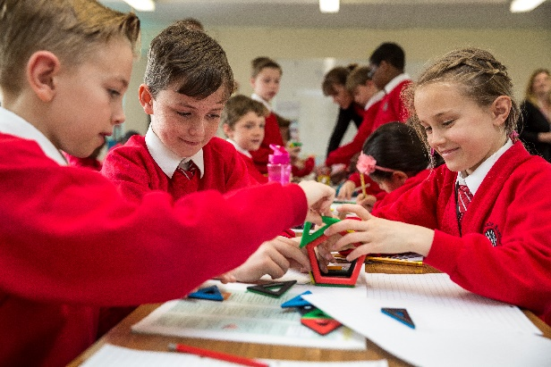
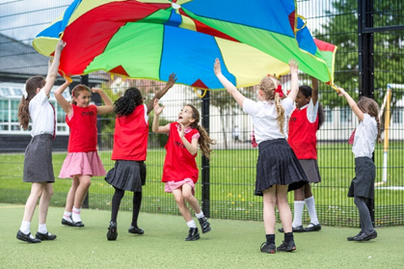
Parklands Times Table Policy
Date of issue: February 2020
Position: Maths coordinator
Date of next review: Spring 2021
Introduction
This policy outlines the teaching, organisation and management of the process and implementation of times tables throughout the school. Times tables are at the heart of mental arithmetic, which in itself, helps form the basis of a child’s understanding and ability when working with number. If a child is secure and fluid with their times tables knowledge, they are able to work more confidently with advanced calculations.
Aims:
- To raise the profile of the teaching of times tables and to raise the overall knowledge of times table facts across the school
- To explain the expected practices, to ensure children learn their times tables
- To ensure continuity in practices and progression in times tables
- To develop mathematical language associated to multiplication and division (e.g. product, multiples of, scale up etc.).
Curriculum and times tables:
Year Group | Tables to be learnt | Beginning | Working towards | Secure
1 | 2,5 and 10 | Children to count forward from any given number to 20 and backwards from any given number to 0. | Children can count in multiples of 2, 5 and 10 with thinking time. | Children can count in multiples of 2, 5 and 10 with fluidity.
2 | 2,5 and 10 | Children can repeat their 2, 5 and 10 times tables in order. | Children can complete 2, 5 and 10 times tables out of order. | Children can complete their 2, 5 and 10 times tables and division facts.
3 | 3, 4 and 8 | Children can repeat their 3,4 and 8 times tables in order. | Children can complete their 3,4 and 8 times tables out of order. | Children can complete 3,4 and 8 times tables and division facts.
4 | 6,7,9,11 and 12 | Children can repeat their 6,7,9,11 and 12 times tables in order. | Children can complete their 6,7,9,11 and 12 times tables out of order. | Children can complete their 6,7,9,11 and 12 times tables and division facts.
5/6 | In years 5 and 6, children should catch up where they have fallen behind on their previous times tables in other year groups.  In these year groups, children should recall multiplication and division facts for all multiplication tables from 1 to 12.  Year 5: Multiply and divide numbers mentally drawing upon known facts  e.g. 30 x 40, 70 x 80, 0.7 x 6  Year 6: To perform mental calculations, including mixed operations and large numbers
Children with SEN | Children to work at a pace appropriate to their needs.

Extra year group requirements:
Year group | Requirement
2 | Count in steps of 3 from any given number, forwards and backwards
3 | Count from 0 in multiples of 4,8, 50 and 100
4 | Count in multiples of 6,7,9,25 and 1000

Teaching Times Tables:
From Monday to Thursday, times tables should be explicitly taught at the start of the mathematics lesson for approximately 10 minutes. Each week, the planning should focus on one times table or be planned from the most recent gap analysis. The planning and teaching of times tables should focus on strategies and techniques to aid the children in understanding the concept of times tables; not just tested.
- Arrays
- Finding patterns
- Making links between known times tables where relevant
Other activities and resources which can support learning of times tables:
- Counting sticks
- Chanting
- Times table grids
- Games and challenges
Testing:
Each Friday, the children should be tested on the times table which has been a focus for that week. The children will complete 60 questions within three minutes using the Times Table Rockstar documents. The children should record their scores in their home/school diaries to share with parents.
At the start of each ICT lesson, years 3 and 4 should complete the online times table activity (URbrainy.com/MTC) which tests their knowledge for instant random recall. The children have 25 questions to answer with a time limit of 6 seconds for each one.
Each term, the whole school will engage with a times tables tournament; they will complete 100 questions in the quickest time possible. Two children from each class with 100% in the fastest time will advance to the final round where there will be an overall winner from each year group.
A gap analysis of children’s results should be used by the teacher to inform planning so that gaps in knowledge can be addressed and target children can be identified.
Differentiation:
It is expected that children will be at varying stages in their times table journey. If children are secure in the times tables which is allocated for their year group, they must be moved on to the times tables from the years above. If they have not yet achieved the target tables for their year groups, they must work on the tables from the year group below. Children who are working on KS1 bands should have extra support in developing an understanding of the concept of ‘lots of’ before moving on to rote learning of any times tables.
Once the children are able to recall all their times table facts, they need to be extended through related number facts, real life problem solving and reasoning.
Home learning:
Times Table Rockstars is a home learning tool which all pupils have access. It is a carefully sequenced programme of times tables practice. Teachers can access and set learning tasks for pupils and children are expected to be actively encouraged to use this platform from home.
At the start of the year, all children were issued with an A2 times table poster which they could refer to at home. This was to encourage engagement with times tables at home with their parents/carers.
Application of times tables in calculation:
(See calculation policy)
Children’s understanding of times tables is only relevant if they are aware of their application in calculations and real life. In order to do this, the children should be using instant recall of times tables when needed in calculations. This awareness can be created in several ways:
- Highlighting when times tables are being used during modelling
- Discussion of how they are being applied during problem solving
- Inclusion of real life examples of times tables application
- Practising times tables on a daily basis
- Marking that identifies misconceptions due to incorrect calculating
Times tables on display:
Times tables should be on display in every classroom for children to use as a support and reference. The display should be large enough for all children to see and table top resources can be used where necessary.

